Document Title: | MVC Functional Safety Plan
Project Short Description: | Volvo SOW2 – Rear and Trailer Camera
Document Owner: | Mohamed Elbeih
Document Responsibility: | Brightskies Software
Document Version: | 0.7
Document Classification: | Confidential
Document Status (Draft | Final): | Draft
Document Archive:

Guidelines for the Document (to be deleted):

In Grey: the instructions for filling the document
In Blue: some guidelines and examples about what should be written.

Document Revision History

Revision No. | Revision Date | Author | Description
0.1 | 13-01-2026 | Mohamed Elbeih | Initial version
0.2 | 19-01-2026 | Mohamed Elbeih | Updates after meetings on 15-01 and 19-01
0.3 | 11-02-2026 | Mohamed Elbeih | Updates after meetings on 28-01, 05-02, 10.02
0.4 | 25-02-2026 | Mohamed Elbeih | Update regarding qualification matrix  Updates after meeting on 19-02
0.5 | 05-03-2026 | Mohamed Elbeih | Updates after meetings on 26-02, 05-03
0.6 | 26-03-2026 | Mohamed Elbeih | Updates after meeting on 12-03, 19-03, 26-03
0.7 | 07-08-2026 | Niklas Hügel | Deleted Safety Activities table and referred to Safety Case Appendix. Added reference to updated RASIC and FIP.

Template Revision History

Revision No. | Revision Date | Author | Description
0.1 | 22/06/2025 | Joel Gamal / Mohamed Elshal | Initial Version
0.2 | 02/07/2025 | Joel Gamal / Mohamed Elshal | Released Version

Safety Development Plan – Approval and modification control

This document is established by the project Functional Safety Manager, and shall be reviewed and approved in compliance with ISO 26262-2:2018 – Table 1

Reviewer | Role | Organization | Verification Review | Approval Date | Revision No.
<reviewer name> | <role> | <BS> | <Link> | <date> | <0.1>

The SDP can be released if all MAJOR or CRITICAL issues are evaluated and closed.

After each major change of the organization and of the tools or methods, the SP is updated:
- Changes in the project deliverables,
- Organizational change,
- Change request: (Ex. Modification of ASIL classification)

The modifications authorization will be done with change management process.

Table of Contents
Acronyms & Definitions 5
References 5
1. Introduction 6
1.1. Purpose 6
1.2. Project scope 7
1.2.1. Safety Project Scope 7
1.2.2. Project Description 7
1.3. Information Security Management 9
1.4. Limitations 9
2. Project Milestones and Timeline 10
3. Management of Functional Safety 11
3.1. Overall safety management 11
3.1.1. Safety culture 11
3.1.2. Management of safety anomalies 12
3.1.3. Competence management 12
3.1.4. Quality management system 12
3.1.5. Project-independent tailoring of the safety lifecycle 12
3.2. Project dependent safety management 13
3.2.1. Project Roles and Responsibilities 13
3.2.2. Assigned Resources 14
3.2.3. Impact analysis at the item level, Reuse of an existing element, Tailoring of safety activities 15
3.2.4. Distributed development 15
3.2.5. Requirements (Customer) 16
3.2.6. Planning and coordination of the safety activities 16
3.2.7. Project Release Planning 22
3.2.8. Progression of the safety lifecycle 23
3.2.9. Safety Case 23
3.2.10. Confirmation measures 23
3.2.11. Release for production 24
4. Concept phase 25
4.1. Item definition 25
4.2. Hazard Analysis and Risk Assessment (HA&RA) 25
4.3. Functional safety concept 25
5. Product development at the system level 26
5.1. Technical safety concept 26
5.2. System and item integration and testing 26
5.3. Safety validation 27
6. Product development at the hardware level 28
6.1. Specification of hardware safety requirements 28
6.2. Hardware design 28
6.3. Evaluation of the hardware architectural metrics 28
6.4. Evaluation of safety goal violations due to random hardware failures 28
6.5. Hardware integration and verification 28
7. Product development at the software level 30
8. Production, operation, service and decommissioning 31
8.1. Planning 31
8.2. Production 31
8.3. Operation, service and decommissioning 31
9. Supporting processes 32
9.1. Supplier Selection 32
9.2. Requirements Management 32
9.3. Configuration Management 32
9.4. Change Management 32
9.5. Documentation Management 32
9.6. Confidence in the Use of Software Tools 33
9.7. Qualification of Software Components 33
10. ASIL-oriented and safety-oriented analysis 34

List of Tables
Table 1: Acronyms & Definitions 5
Table 2: References 5
Table 3: Project Information 7
Table 4: Safety goals for SOW2 7
Table 5: Assigned Resources 14

Acronyms & Definitions
The following acronyms appear throughout the text.

Acronym / Term | Full Form / Definition
BS | Brightskies Software
DIA | Development Interface Agreement
HSI | Hardware-Software Interface
IL | Independence Level
MVC | Mekra Vision Controller
POSD | Production,m Operation, Service and Decommissioning
SAD | System Architecture Design
SOW | Scope Of Work
SX | Solectrix
TSC | Technical Safety Concept
Table 1: Acronyms & Definitions

References
The applicable standard documents for the project are:

Ref. | Filename | Description | Author | Date | Version
Ref.1 | ISO_26262-X_2018(en) | Road vehicles — Functional safety Standard | ISO | 2018-12 | 2.0
Ref.2 | D030999--[15] Compliance Matrix Functional Safety QDPR.pdf | Development Interface Agreement | Volvo | 2024-10-17
Table 2: References

Introduction
The safety development plan (SDP, this document) is the main planning document for functional safety. It identifies and describes all functional safety activities which are planned to be carried out for the specified project during the lifecycle of its product under development. It is the functional safety specific part of the whole project.
The ultimate goal of the safety development plan is to compile a system safety case that communicates a clear, comprehensive, and defensible argument that
(1) the safety mechanisms of the system produced by the development activities have been analyzed and tested and that
(2) the risks to human beings associated with operation of the product in an automotive vehicle is at an acceptable level.

Purpose
This SDP mainly describes functional safety project specific items, citing parts from ISO 26262-X: 2018 where relevant:
- Objectives to reach (as defined with the customer during elicitation phase),
- Project description,
- Project team description,
- Applicable documents to the project,
- Project schedule,
- Project deliverables,
- Safety project organization
  - Project roles and responsibilities
  - Customer involvement
- Planned safety activities
  - Planned work products
  - Supporting processes

Project scope

Safety Project Scope

Project Information
Project ID | 11-E-01405 / 11-P-01467
Project Name | Volvo SOW2 – Rear and Trailer Camera / MVC - MEKRA Vision Controller
Customer | Volvo
Initial Project schedule
Start Date/Week of the Project | 02.09.2024 (Project kickoff)
End Date/Week of the Project | 17.03.2028 (SOP + 6 months)
Table 3: Project Information

The table below provides a comprehensive listing of all safety goals assigned by the customer to SOW2 system, associated with ASIL rating:

Safety Goal | Description | ASIL
SG1 | The system shall avert showing a delayed traffic situation in its video output at any time. The maximum delay shall not exceed 50ms | B
SG2 | The system shall avert a frozen image.  Remark 1: The image is considered frozen, when given frame gets repeated.  Remark 2: Due to technical implementation, one (single!) repetition of the frame may be allowed. | B
SG3 | The system shall display the environment realistically at any time regarding contrast and brightness, to avoid losing any detail, which could end up in a hazard. Video frames causing an unclear view (too dim, too low contrast, too much disturbances or noise, wrong resolution, flicker, too low frame rate) shall not be transmitted | A
SG4 | The system has to show correct angle of view, zoom factor and visual field at any time. | B
Table 4: Safety goals for SOW2

Project Description
Development of an ECU that is integrated in a camera adapter housing and into which a raw data camera will be plugged. A shutter function, a metal holder and an adapter cable are being developed as optional extras. A slim and standard version is being developed.
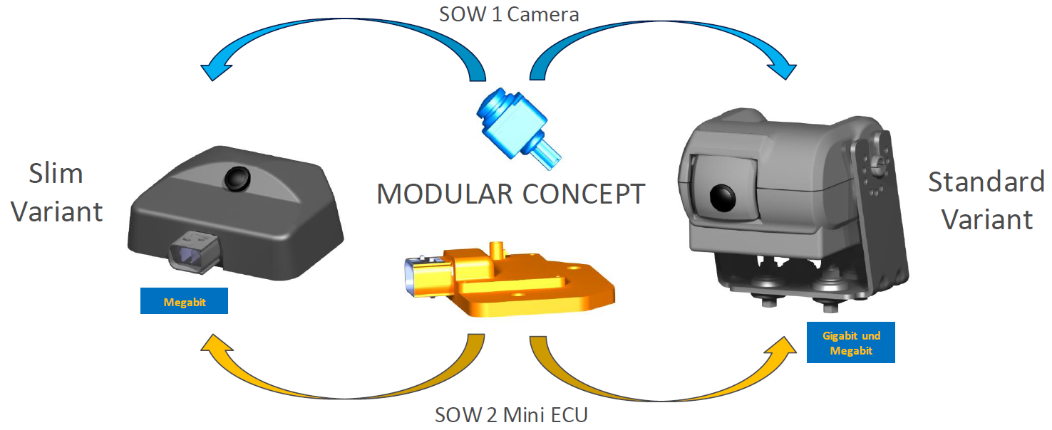
Figure 1: SOW2 system overview

The overall project planning, which is in the responsibility of the project manager, provides the basis for the safety plan.
The project master sheet (“Projektstammblatt”) describes the MEKRA framework conditions of the project:
Link: D027522/ D024973 - Projektstammblatt SOW2

The SOW2 Kickoff overview, describes project scope and project milestones:
Link: D029931- Kickoff SOW2

Information Security Management
The shared information and data transferred from and to the client shall be protected all the time. Only team members are given access to view the data that concerns their part of work to ensure the information security between Mekra Lang and Brightskies Software.

MEKRA has achieved TISAX label, with assessment level 3.
Brightskies Software has achieved TISAX label. It confirms that the company’s information security management system complies with defined security levels and allows sharing of assessment results across TISAX platform.
Brightskies TISAX Label Data:
- Scope ID: SHX8YP
- Assessment ID: AKX8YP-1
- location IDs : LN3T6K & L58915
- Label validity : 14/09/2025

Limitations
No limitations known at this time.

Project Milestones and Timeline
Overall project time schedule:
CDB/ 11-E-01405 SOW2 – Rear and Trailer Camera RFP – Volvo/ Documents/ Project Documentation/ Time Schedule
Refer to chapter “Planning and coordination of the safety activities”

Management of Functional Safety
ISO 26262:2018 specifies requirements with regard to specific phases and sub-phases of the safety lifecycle (See the figure below), as well as requirements that apply to all or multiple phases of the safety lifecycle. These are the requirements for effective management of functional safety.
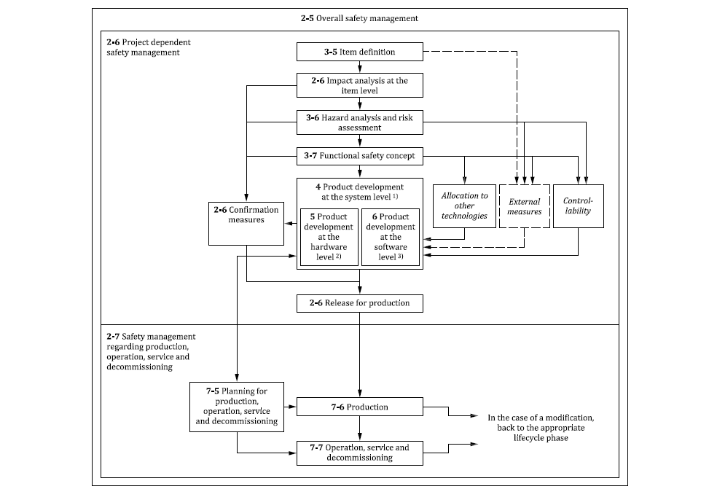
Figure 2: Safety Lifecycle as defined by ISO 26262, reference ISO 26262

The following sections describe the planned FuSa management activities and deliverables

Overall safety management

Safety culture
MEKRA follows the overall goal of developing, producing and commissioning functional safe products. Product safety is the top priority and has priority over cost and time constraints. Compliance with the safety culture is part of the role description of every member of the organization.
Following the safety activities (required by ISO 26262) is ensured through using the company’s generic product development process. The necessary resources are therefore also allocated as required.
Link: MEKRA product development process
Qualified resources must have the appropriate competence for the assigned activity, which is ensured via the employee-specific competence matrix. Qualified employees in the area of functional safety are part of the training objectives of the respective department heads. For privacy policy reasons, the personal competence matrixes can be viewed via the department heads or the HR department.

Management of safety anomalies
Safety anomalies are handled by defect management process.

Link: Defect Management Process

Competence management
To ensure that the involved persons have a sufficient level of competence in the execution of safety lifecycle, the qualification and capability of the project member will be regularly monitored and trained according an individual competence matrix for every specialist department. The respective competence matrixes can be viewed via the department heads or the HR department.
A dedicated functional safety manager and functional safety engineer supports the project and is part of every project team.

Quality management system
MEKRA is certified according to ISO 9001, IATF 16949 and ensures compliance with functional safety management throughout the company's generic product development process.

Brightskies has achieved the ISO 9001 quality management system certificate. It demonstrates the organization commitment to quality and continues improvement.

Project-independent tailoring of the safety lifecycle
MEKRA has defined the safety lifecycle, including safety activities divided into the respective project phases, project- independent through the company’s generic product development process.
Link: MEKRA product development process
Tailored activities are assigned to customers, development partners or suppliers based on the MEKRA product. (e.g. HARA, FSC, SW-development)

Project dependent safety management

Project Roles and Responsibilities

Project Management
The PM is responsible for the planning, tracking, and performing adjustments, as appropriate, of functional safety activities. The PM role is:
- to ensure the completion of the project activities and work products within the project time schedule;
- to ensure that sufficient resources and tools are available in the project;
- to ensure that safety related issues are communicated and action items are tracked;
- to ensure that the safety activities are carried out as planned in the Safety Plan.

Project Functional Safety Manager
The project functional safety manager is responsible of managing the project functional safety activities workflow and work products. The PFSM role is:
- to prepare the safety plan, components safety manual and safety case in the project;
- to ensure that all work products meets all functional safety requirements for this project;
- to manage the safety plan and track progress in the safety activities and work products for the duration of the project;
- to tailor decisions in the project safety lifecycle according to the component ASIL in order to comply with ISO 26262:2018;
- to manage the certification process in the project.

System Safety Engineer
The system safety engineer is responsible for designing the system safety architecture. The SYS_SAF_ENG role is:
- deriving system safety requirements and performing system safety analysis;
- implementing system safety mechanisms after analysis;
- Determining safety tools and methods for system’s verification and validation, and executing the system’s verification and validation activities.

Hardware Safety Engineer
The hardware safety engineer is responsible for designing the hardware architecture as per the required automotive safety integrity level (ASIL). The HW_SAF_ENG role is:
- implementing hardware safety requirements into the hardware design architecture, including AOUs as they related to the hardware;
- performing safety analyses to confirm that the hardware design is meeting the required ASIL metrics;
- Planning, specifying, and executing hardware-level integration testing.

Software Safety Engineer
The software safety engineer is responsible for developing and implementing safety mechanisms in the source code. The SW_SAF_ENG role is:
- Performing software safety analysis and Deriving software safety requirements;
- Implementing software safety mechanisms after analysis;
- Updating component design document after safety mechanisms implementation;
- Confirming traceability between SW requirements and test cases.

Functional Safety Assessor
The FSA (when applicable) role is:
- to be an external eye regarding functional safety on a project. He is independent regarding the people in charge of the project. He must have an overall view on the project as opposed to other peers that may be involved in verification reviews of dedicated work products.
- to perform Safety Assessment Reviews in the project.
- to participate to all Confirmation Review of the project as an inspector
- when applicable, to check the conformance of the work product to the safety standards

Assigned Resources

Role Description | Current Responsible | Contact
Project Manager | Johannes Schwarzbeck | johannes.schwarzbeck@mekra.de
Functional Safety Manager (MEKRA) | Niklas Hügel | niklas.huegel@mekra.de
Project Functional  Safety Manager (BS) | Mohamed Elbeih | mohamed.elbeih@brightskiesinc.com
System Safety Engineer | Miroslaw Rekas | miroslaw.rekas@mekra.de
HW Lead Engineer | Agron Sheqiri  Andreas Dünisch | agron.sheqiri@mekra.de  andreas.duenisch@mekra.de
SW Lead Engineer | Haitham Ibrahim | haitham.ibrahim@mekra.de
Functional Safety Assessor | Refer to Assessment Plan
Functional Safety Auditor | TBD
Table 5: Assigned Resources

The project specific responsibilities are described within a Stakeholder-Communication-Matrix.
Link: Stakeholder-Communication-Matrix

The required FuSa skill levels are managed via the template “qualification matrix”.
It is managed and stored confidentially for each team by its own team leader. A screenshot from qualification matrix template is shown below.

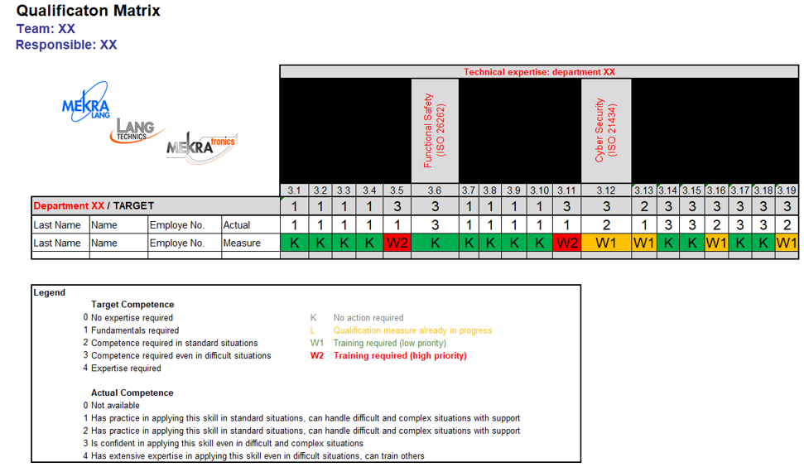

Impact analysis at the item level, Reuse of an existing element, Tailoring of safety activities
The impact analysis is performed within a separate documentation. The document is referenced in the table “MEKRA Functional Safety Activities” document “Safety Case Appendix”.

Link to Impact Analysis:
D032847/a Functional Safety_Impact analysis_SOW2 (Functional Safety)

Distributed development
In addition to the in-house development of an ECU, integrated into a camera adapter housing, MEKRA is outsourcing the software development to the suppliers Solectrix and Brightskies.

Brightskies Software is supporting MEKRA with some functional safety activities. The distribution of safety activities between BS and MEKRA is defined in chapter ‘3.2.6 Planning and Coordination of the Safety Activities’.

Development Interface Agreements (DIA)
The customer VOLVO and the supplier MEKRA have specified the roles and responsibilities for the divided safety activities through a Functional Safety QDPR Compliance Matrix.
Link: Functional Safety QDPR Compliance Matrix

MEKRA as a customer of Solectrix, Brightskies and Ambarella has specified the roles and responsibilities for the divided safety activities through a Development Interface Agreement (DIA)
Document: D043543--SOW2_RASIC_DIA_CIA_with_SX_BS_AMBA - Index M_signed.pdf

Joint Reviews
- MEKRA – VOLVO, on a monthly basis: “SOW2 – Joint Reviews via AVA (VOLVO Portal)”
- MEKRA – SX, on a monthly basis: “SOW2 Abstimmung Q-Themen”
  - Additionally several meetings/alignments between development departments

Requirements (Customer)
Customer specific requirements which are related to the Functional Safety are referred within the chapter “Planning and coordination of the safety activities” document “Safety Case Appendix”.

Planning and coordination of the safety activities
The safety activities to be planned and monitored by MEKRA are resulting from the following inputs:
- ISO 26262:2018
- D025374/ [11] Functional Safety Quality and Development Process Requirements (FS-QDPR) – TECH-198649292-269_Version 6.0
- D030999/ [15] Compliance Matrix Functional Safety QDPR (signed between VOLVO and MEKRA)
- D043543--SOW2_RASIC_DIA_CIA_with_SX_BS_AMBA - Index M_signed.pdf
- D032847/ Functional Safety_Impact analysis_SOW2

This diagram shows the product development process at MEKRA:

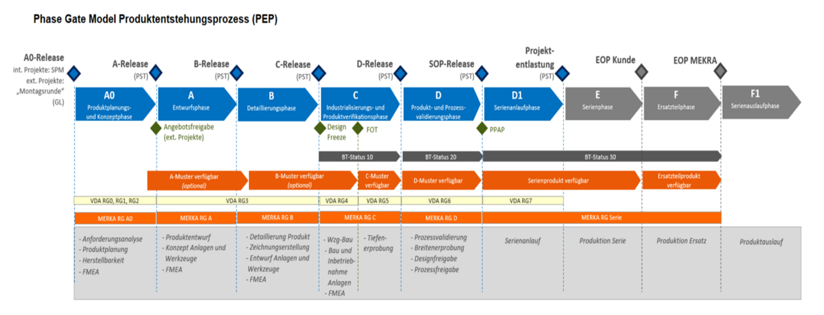

This diagram shows the development phases at Volvo:

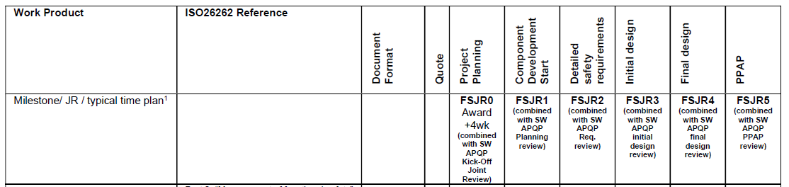

This table maps the development phases of Volvo to development phases of MEKRA:

Volvo phase | FSJR0 | FSJR1 | FSJRX | FSJRX | FSJRX | FSJRF
MEKRA phase | Phase A0 | Phase A | Phase B | Phase B | Phase C | Phase D
Time Point | CW49/2024 | CW08/2026 | CW09/2026 | CW10/2026 | CW52/2026 | CW17/2027

For tailoring of safety activities see as “single point of truth” the agreed FUSA QDPR Compliance Matrix between VOLVO and MEKRA.

The planned functional safety activities are defined and tracked via the “Safety Case Appendix_vx.x”
The document additionally contains a schedule for planning the duration and dependencies of all activites.
Link: https://polarion.mekra.net/polarion/svnwebclient/directoryContent.jsp?url=Intern%2F11_P_01467_MEKRA_Vision_Controller%2FProject%20Files%2F02%20Development%2FFunctional%20Safety%2FWork%20Products%2FManagement

Project Release Planning
The project related release planning will be performed with the requirement management tool “Polarion”.
Link: https://erg-polarion-p1.mekra.net/polarion/#/project/11_P_01467_MEKRA_Vision_Controller/wiki/94_Release_Planning/Home

Extract of the initial FUSA related release planning:
* Changes currently being processed

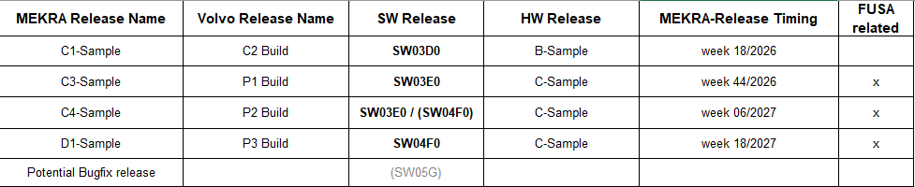

The detailed FUSA related release planning is done within the D042640/ FeatureImplementationPlan (Software)

Progression of the safety lifecycle
In the case of a lack of information from the pertinent preceding sub-phases, the subsequent sub-phase only starts if the lack of information does not cause an unreasonable risk regarding functional safety.
Due to the company’s generic product development phase model, each project phase progression must be released by a management team. Based on a project maturity level analysis according to “VDA – Reifegradabsicherung für Neuteile”, all open work products for the target phase change are indicated for the release procedure. The management team decides whether the new project phase may be started or not.

Safety Case
The Safety Case is providing the argument for achieving functional safety.
The argument will be supported by a compilation of the work products created during the safety lifecycle.

Confirmation measures
The functional safety of the MEKRA product will be confirmed, based on performing confirmation reviews, functional safety audit and functional safety assessment.

Confirmation reviews
The key work products (listed in ISO 26262-2:2018 - Table 1) will be judged whether they provide sufficient and convincing evidence for the achievement of functional safety.
Upon completion of a confirmation review, the work product may be accepted without major corrections, conditionally accepted or rejected.
The confirmation reviews need to be finalized before the release of production.
The confirmation and verification reviews will be combined as permissibly described in the standard [ISO 26262-2:2018 – 6.4.10.5].
The completed confirmation and verification reviews are linked from the document “Safety Case Appendix” linked within the table “MEKRA Functional Safety Activities” related to the key work products.

Functional safety audit
Supplier MEKRA:
MEKRA is planning to carry out a functional safety audit according the VOLVO requirement coming from the “FS-QDPR, chapter 7.2” and “ISO 26262-2:2018, chapter 6.4.11”.
The finalization will be latest before the release of production.
BS is planned to carry out the audit.

After the performance of the audit, the audit report to judge the functional safety processes of the organization and development site will be available.

Sub-suppliers:
The sub supplier functional safety audit will be carried out separately from MEKRA audit.
Affected sub suppliers: Solectrix Brightskties as part of MEKRA

Functional safety assessment
MEKRA is planning to carry out a functional safety assessment according the VOLVO requirement coming from the “FS-QDPR, chapter 7.3” and “ISO 26262-2:2018, chapter 6.4.12”.
The time point will be at the stage of a final realized system and latest before the release of production.
A person or party to carry out the assessment is still to be defined.
BS is planned to carry out the assessment

After the performance of the assessment, the functional safety assessment plan and report to judge whether the objectives of the ISO 26262 series of standards are achieved will be linked here.

SX will be consultant for the “FUSA assessment”, therefore SX activities will also be considered during the overall FUSA assessment hold by BS at MEKRA side.

Functional safety assessment plan
Timing: Before PPAP preparation joint review (CW17/2027). To allow for time needed to take any actions, it is recommended to have the assessment at the start of 2027.

Release for production
The release for production of the considered element can only be approved as soon as sufficient evidence for the achievement of functional safety is available.
The evidence will be provided in form of a summarized documentation that confirms the completeness of the safety case and all necessary confirmation measures.

Concept phase

Item definition
According to ISO 26262-1:2018 (Vocabulary of Functional Safety) “items” are defined as systems or combination of systems, that implement a function or part of a function at the vehicle level (Behaviour of vehicle, which is observable by the OEM, e.g. an automatic cruise control [using different ECU’s and a variety of sensor technology]).

SOW2 is viewed as a system and not viewed as an item, since SOW2 on its own does not do a complete function that’s perceived by the vehicle driver or passengers.

The Item definition includes a description of the item with regard to its functionality, interfaces, environmental conditions, legal requirements, and known hazards. The boundary of the item and its interfaces, as well as assumptions concerning other items, elements, or external measures are determined.

According to the RASIC coming from the Functional Safety QDPR compliance matrix, the responsibility lies on VOLVO side.

Hazard Analysis and Risk Assessment (HA&RA)
The hazard analysis and risk assessment estimates the probability of exposure, the controllability and the severity of the hazardous events with regard to the item. Together, these parameters determine the ASILs of the hazardous events. Subsequently, the hazard analysis and risk assessment determines the safety goals for the item.

According to the RASIC coming from the Functional Safety QDPR compliance matrix, the responsibility lies on VOLVO side.

Functional safety concept
The functional safety concept derives the functional safety requirements from the safety goals and by allocating these functional safety requirements to the elements of the item.

The Functional Safety Requirements are provided by VOLVO within the technical requirements document (TR) derived from the safety goals. Those requirements are considering only the high system level from vehicle perspective.
Based on those functional safety requirements on high system level, MEKRA will extend to them the functional safety requirements on element level, as interface requirements before defining the technical safety requirements.
The MEKRA Functional Safety Concept will allocate the functional safety requirements (on element level) to the element architecture and will specify the functional safety validation criteria.
The MEKRA Functional Safety Concept is described in Polarion.

Product development at the system level

Technical safety concept
The Technical Safety Concept (TSC) specifies safety requirements allocated to the elements of the system architecture, hardware and software. In so doing, it must consider system properties such as the external interfaces, constrains, configuration requirements, as well as dependencies between elements of the system, it also specifies the technical safety requirements and verifies that the technical safety requirements comply with the functional safety requirements.

The major component of the TSC is specification of technical safety requirements, which are to provide measures to:
- Detect, indicate, and control faults in the system itself.
- Detect, indicate, and control faults in the external devices interacting with the system.
- Enable the system to achieve or maintain a safe state.
- Prevent faults from being latent.
- Avoid systematic failures.

Technical safety concept shall also include:
- System architectural design specification which implements the technical safety requirements.
- Hardware-software interface (HSI) specification which specify the hardware and software interaction includes the component's hardware parts that are controlled by software and hardware resources that support the execution of the software.
- Specification of requirements for production, operation, service and decommissioning.

System and item integration and testing
Integration and test strategy documents the plan to ensure that the system elements are integrated in a planned and controlled manner and that system-level safety requirements are verified. This also includes methods for deriving test cases for integration testing.
Test methods recommended according to ISO26262 shall be mentioned in the test strategy
Reference to the document can be found in the “Safety Case Appendix”.
Integration and test report provides the documented evidence of the results and analysis from the execution of the system-level integration and testing activities.

According to the RASIC coming from the Functional Safety QDPR compliance matrix, the responsibility of vehicle integration and testing lies on VOLVO side.

SOW2 integration is considered HW-SW integration MEKRA responsibility.

SOW1+SOW2 integration is not considered part of MEKRA responsibility, as MEKRA has only received requirements related to SOW2. as aligned with VOLVO in the RASIC
D029096/ (04) RASIC Rear and chassis camera (Customer Request)

Item integration is considered vehicle integration OEM responsibility. Refer to ISO Part 4. Requirement 7.4.4.1.2

Safety validation
The safety validation specification and report provides evidence that the implemented safety goals achieve functional safety for the item.

According to the RASIC coming from the Functional Safety QDPR compliance matrix, the responsibility lies on VOLVO side.

Product development at the hardware level

Specification of hardware safety requirements
Hardware safety concept includes hardware safety requirements specification as well as the refined hardware-software interface specification (HSI) which was previously initiated at system level to allow for the correct control and usage of the hardware by the software and shall describe each safety-related dependency between hardware and software.

Hardware design
Hardware design specification defines the architecture of the hardware that will implement the hardware safety requirements allocated to hardware elements. It describes how various hardware components interact with each other and contribute to the overall functional safety of the item
It also includes the HW safety analysis.
- In order to avoid systematic faults the hardware architectural design shall exhibit the following properties by use of the principles listed in Table 1 of ISO 26262-5.
- Safety analyses of the hardware design to identify the causes of failures and the effects of faults shall be applied in accordance with Table 2 of ISO 26262-5 and ISO 26262-9:2018, Clause 8.
- The hardware design shall be verified in accordance with ISO 26262-8:2018, Clause 9, and by using the hardware design verification methods listed in Table 3 of ISO 26262-5 to provide evidence for fulfillment of hardware safety requirements, compatibility with HSI specification and suitability of the safety-related special characteristics to achieve functional safety during production and service.
It also includes the specification of requirements related to production, operation, service, and decommissioning

Evaluation of the hardware architectural metrics
The primary purpose of the FMEDA report is to analyze and document the effectiveness of the hardware architecture of the item (the complete system being developed) in dealing with random hardware failures. It provides objective, quantitative evidence that the hardware design, including its implemented safety mechanisms, can prevent, detect, and/or mitigate the effects of random hardware faults to meet the probabilistic targets defined by the assigned Automotive Safety Integrity Level (ASIL). It includes Probabilistic Metric for Random Hardware Failures (PMHF), Single Point Fault Metric (SPFM) and Latent Fault Metric (LFM).

Evaluation of safety goal violations due to random hardware failures
It includes the Evaluation of Probabilistic Metric for random Hardware Failures (PMHF) as well as dedicated measures for hardware.

Hardware integration and verification
The purpose of hardware integration and verification specification is to verify that the integrated hardware fulfills its hardware safety requirements and contributes to the overall system's functional safety.
- To provide evidence that appropriate test cases for the selected hardware integration tests are specified, test cases shall be derived using an appropriate combination of methods as Table10 of ISO 26262-5.
- The hardware integration and verification activities shall verify the completeness and correctness of the implementation of the hardware safety requirements (consider Table11 of ISO26262-5)
- The hardware integration and verification activities shall verify the durability and robustness of hardware against environmental and operational stress factors (consider Table12 of ISO26262-5).
The selection of these provided methods are described within the HW Test Strategy
(Take over to HWE.3/4 Strategy – include FUSA part) @HW Team MEKRA

Product development at the software level
The product development at software level is out sourced to the sub-supplier Solectrix Brightskies. Polarion is used as a joint working platform to ensure a clean interface between system and software development. The division of responsibilities between the system and software level is defined by a Development Interface Agreement (DIA) as described above.
According the DIA the sub-suppliers functional safety plan is in Solectrix responsibility.
Descriptions to be added by BS, including reference to methods according ISO (table 1 – 15) and SW Test Strategies/ Plans.

Production, operation, service and decommissioning

Planning

Production
Safety-related content of the production plan
Safety-related content of the production control plan, including test plan
Producibility requirements specification

Pre-Production
Production process capability report

Operation, Service, Decommissioning
Safety-related content of the service plan
Safety-related content of the service instructions
Safety-related content of the information made available to the user
Safety-related content of the decommissioning instructions
Operation, service and decommissioning requirements specification
Safety-related content of the rescue services instructions

Production

Control measures report
Production process capability report

Operation, service and decommissioning

Field observation instructions

Supporting processes

Supplier Selection
The supplier selection process considering the aspects of ISO 26262 series of standards is realized through a supplier self-assessment process before the nomination. The result of the supplier self-assessment will be subsequently assessed by a MEKRA specialist team. The content of the self-assessment checklist covers for example: Evidence of the supplier’s quality management system, the previous performance and quality of the supplier and confirmation of the suppliers capability in functional safety.
The evidences of the performed and evaluated selection reports are stored within the purchasing department. A reference is to be found in the table “MEKRA Functional Safety activities”.

Requirements Management
The requirement management process shall support:
- Requirements Structure check;
- Traceability between functional safety requirement and technical safety requirements shall be stated.
- Traceability between technical safety requirement and hardware and/or software safety requirements shall be stated.
- Traceability between requirement and test cases shall be stated.

To indicate the relevance of some requirements regarding functional safety, attributes with defined values shall be added.

Link: Polarion Requirements Management

Configuration Management
The configuration management shall assure:
- Unique identification of product configuration;
- Unique identification of each element of the configuration;
- Configuration rules (Baseline creation rules);
- Configuration plan.

Change Management
Any change in the scope of work held between MEKRA and customer or suppliers shall be requested by a change request (CR) in which both parties should agree to the new SOW and the new estimated hours.

Documentation Management
The Documentation Management aims to define how documentation will be planned, created, organized, stored, updated, and maintained throughout the safety lifecycle and ensure all safety-relevant work products are traceable, version-controlled, and accessible for review, audit, and reuse.

Confidence in the Use of Software Tools
The primary purpose of Software Tool Criteria Evaluation Report is to document the evaluation of a software tool against defined criteria to determine the necessary confidence in the tool and, consequently, whether tool qualification is required. It establishes the tool's impact on functional safety.
The Software Tool Qualification Report provides the documented evidence that a software tool is suitable for its specific intended use in a safety-related development environment and meets the required Tool Confidence Level (TCL).

Mekra shall do the evaluation of system and hardware level SW tools.
Solectrix shall do the evaluation of software level SW tools.

Qualification of Software Components
Software component documentation aims to provide a comprehensive and accurate record of the software component's architecture, design decisions, interfaces, and implementation detail.
Software component qualification provides documented evidence that a particular software component not developed to a specific ASIL meets the necessary safety, reliability, and functional requirements for its intended use within the safety-related item.
SW qualification is planned for SW drivers targeting ASIL B. Those drivers are:
- Image sensor driver
- SerDes driver

ASIL-oriented and safety-oriented analysis
Safety analysis activities and work products are covered under system, HW and SW activities.

